**Local Air Quality Study – Prince George, BC, 2018**

Introduction

The city of Prince George, located in Northern British Columbia, has a population of approximately 74,000 (BCStats, 2016) and is situated at the confluence of the Nechako and Fraser Rivers in a valley approximately 150 meters below the BC Central Interior Plateau (Fig. 1). The city has gained notorious reputation for poor air quality and some of the highest pollutant levels in BC. This study particularly looks at the PM2.5 data gathered at Plaza 400 (marked as a red star in Fig. 1) for the year of 2018. PM2.5 is the fine particulate matter with particles smaller than 2.5 microns and comes mainly from combustion sources such as industrial operations, vehicles and wood smoke but can also be a byproduct from chemical reactions among pollutants and components of the atmosphere. Fine particulates pose significant threat to human health because their small size lets them deeply penetrate lung tissue, and in some cases even the bloodstream posing danger to lung and cardiac health.

Prince George’s air quality problems can be hypothesized as a combination of meteorology, topography and land use. Approximately 44 industrial operations currently hold air emissions permits in and around Prince George which includes three pulp mills, an oil refinery, two asphalt plants, a host of sawmills, wood product plants and chemical operations. Geographically the city is in a bowl-shaped valley, 450 km from the Pacific Ocean, and more than 500 km and 600 km, respectively, from the nearest major urban centers of Vancouver and Edmonton; making Prince George isolated from anthropogenic emission sources outside its own airshed. Additionally, atmospheric stagnation events due to anticyclonic conditions, thermal inversions and light winds in the valley often result in aggravated air conditions. Frequent summer-time forest fires in the province also degrade air quality in Prince George. This paper aims to detect and exemplify some of these instances from the diurnal and seasonal data acquired in 2018, discuss any anomalies, sources, sinks and exceedances in the scope of Prince George’s PM2.5 concentration.

Data Acquisition and Observations:

The PM2.5 data and PM2.5 24-hour running average data was acquired from the Air Quality Health Index (AQHI) data archive found on the BC Air Quality website. The data reported all PM2.5 concentrations in µg m-3 and was compared with the Canada Wide Standard (CWS) for PM2.5 at 28 µg m-3 for a 24-hour running average to detect exceedances and their potential explanation.

First the raw data was plot as a timeseries of PM2.5 concentration against time. As seen in Fig.3 1, there is a largely noticeable peak around the summer months, particularly mid-August to mid-September that reaches almost 630 µg m-3. Other noticeable peaks occur around April at 170 µg m-3 and others in February, June and October each around 100 µg m-3. Graph 1 alone does not provide a holistic view of the trend in PM2.5 and so further analysis was carried out by splitting the data into seasonal trends. Seasons are defined as the following:

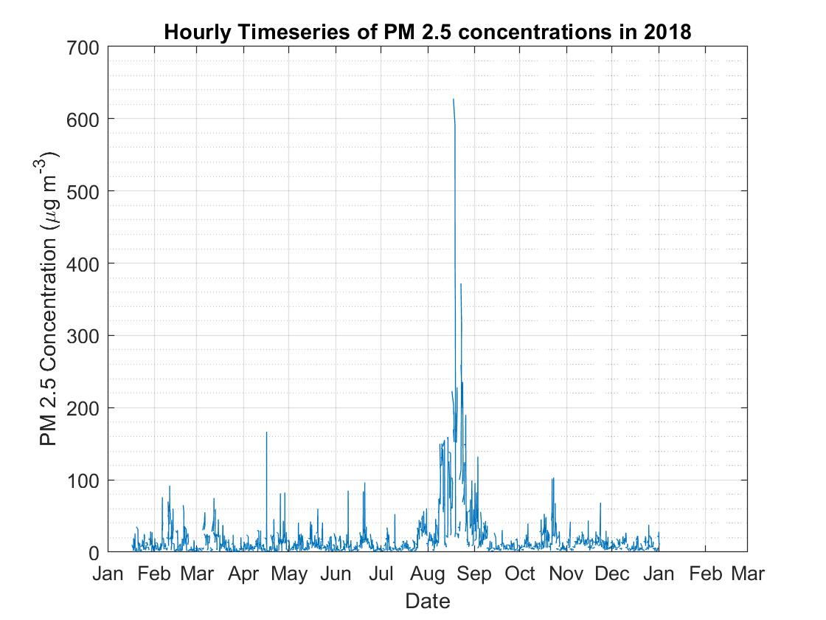

Graph 1:Timeseries of the raw PM2.5 concentration in 2018. Data starting on January 16, 2018 upto January 16,2019

* Winter- January, February, March
* Spring- April, May, June
* Summer- July, August, September
* Fall – October, November, December

Graphs 2 through 5 below show the raw PM2.5 data split into 4 seasons and represented as boxplots that show the range of PM2.5 concentrations through the course of the day, for that season. As seen in Graphs 2 to 5, summer months have the highest number of outliers from all the however the diurnal variation is similar to the rest of the graphs. Highest concentrations of

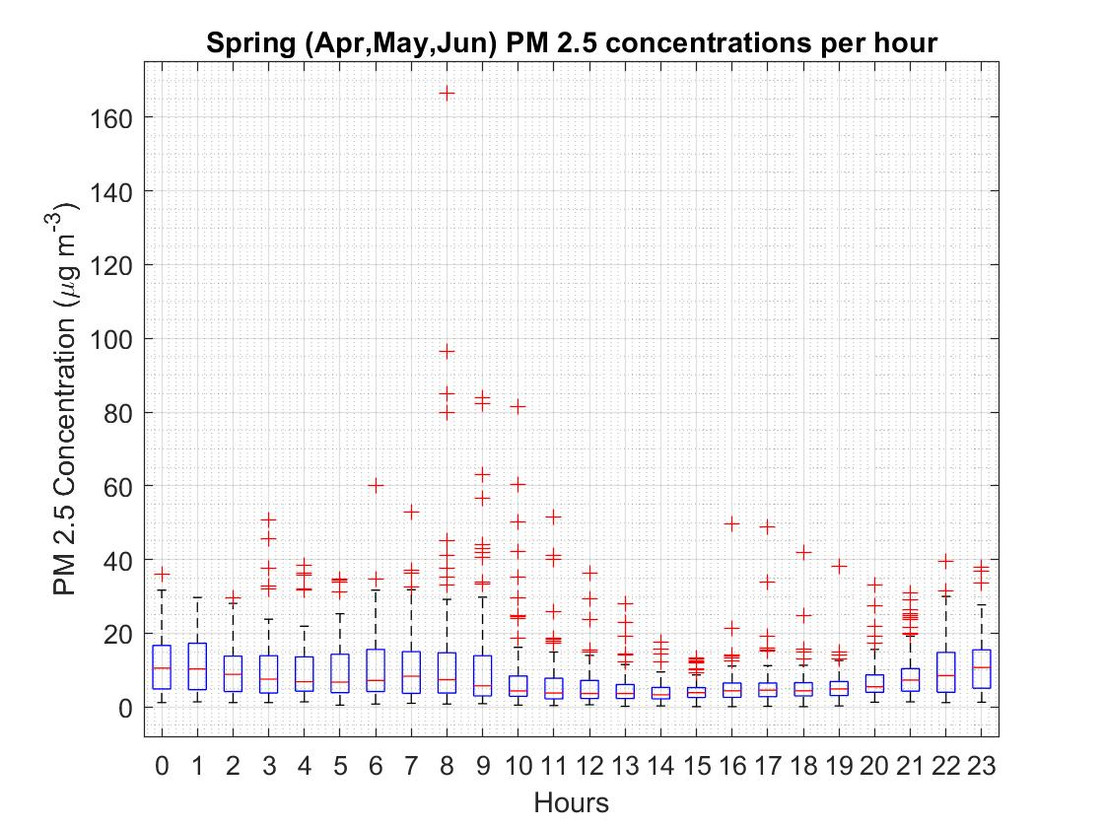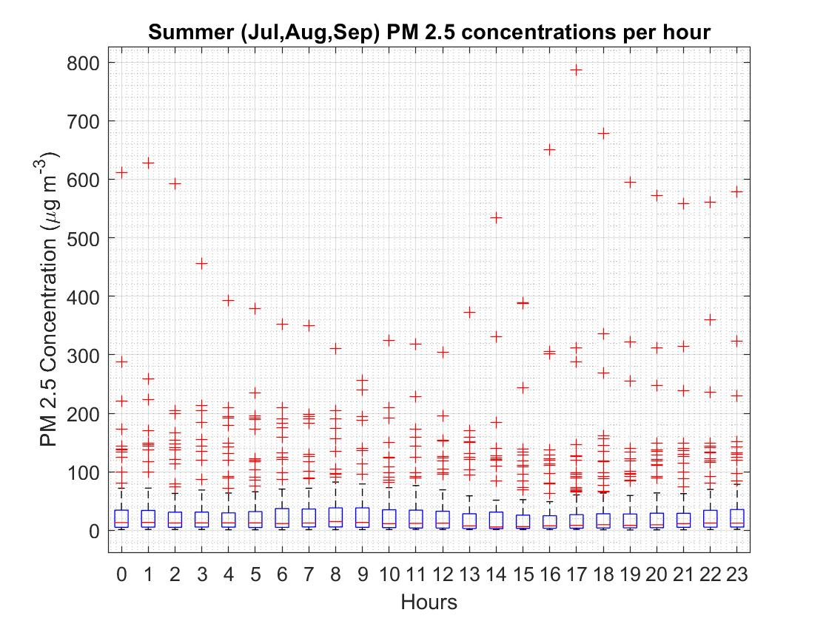

PM2.5 are seen during Spring and Summer. The concentrations are lower during fall and winter, with even outliers reaching a maximum of 100 µg m-3. In diurnal trends, from studying the medians we see that concentrations are usually lowest between noon to sunset and higher overnight. This trend is common to all the 4 seasons distinguished.

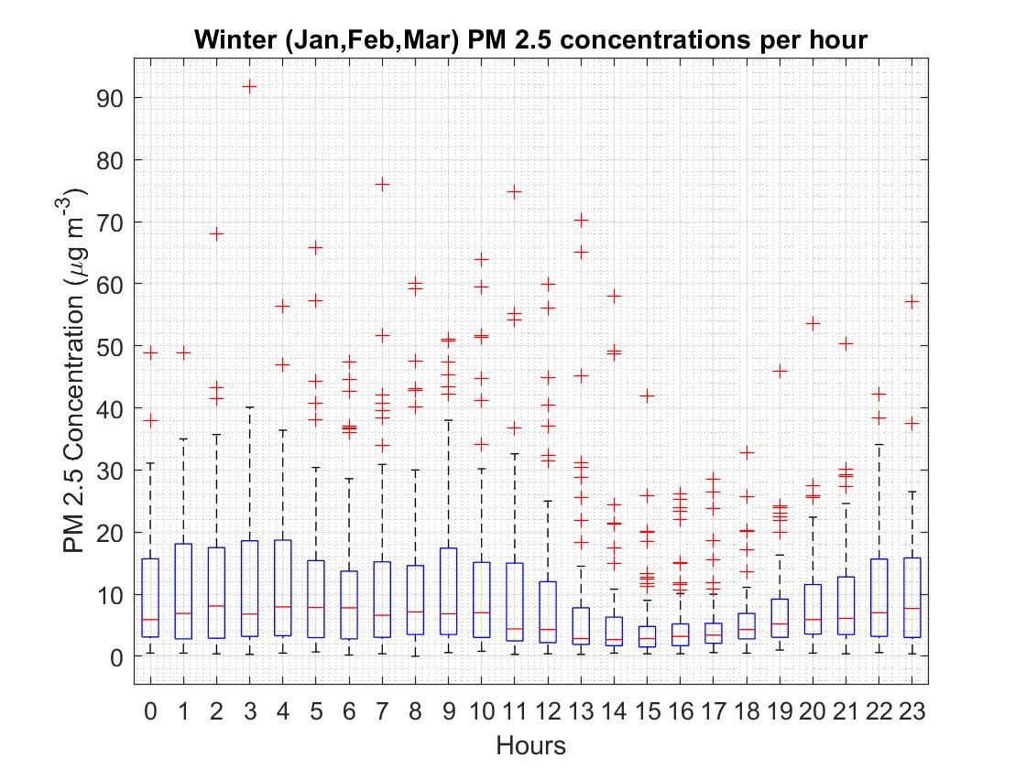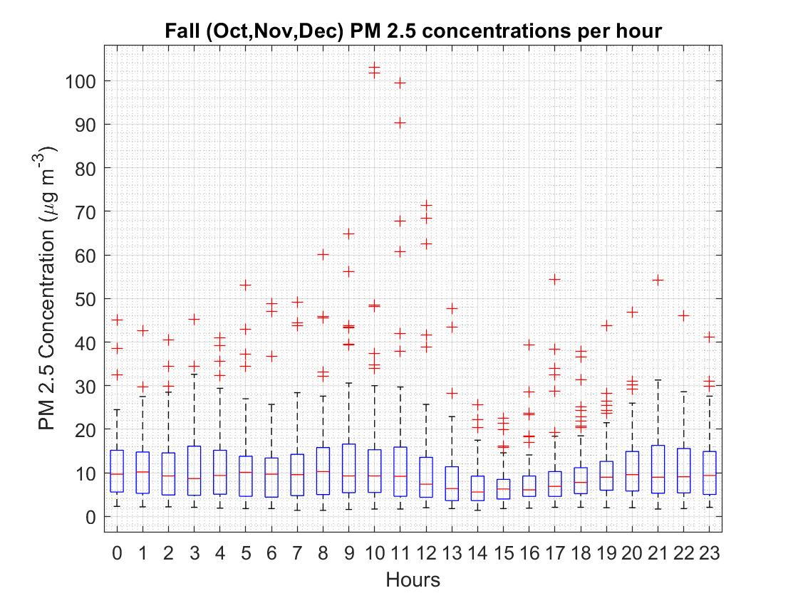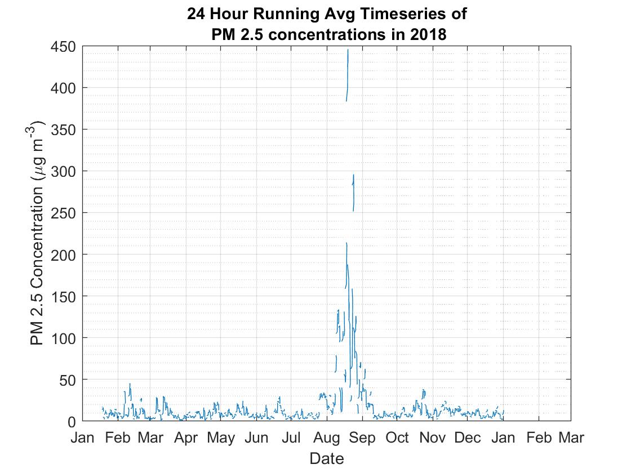

Graph 3:Timeseries of the 24-hour running average of PM2.5 concentration in 2018. Data starting on January 16, 2018 upto January 16,2019

Similarly, an hourly timeseries and seasonal boxplots were also created for the 24-hour running average of the PM2.5 concentrations. The timeseries for this dataset is shown in Graph 6. The averaged data from Graph 6 has beaks at lower concentrations than seen in Graph 1. While the occurrence of these peaks aligns with the peaks from Graph 1, the largest peak occurs close to 450 µg m-3, while the others remain under 50 µg m-3. Graphs 7,8,9 and 10 are the diurnal boxplots split by season of the 24-hour running average of PM2.5 concentrations as seen each hour. An additional line is added at y = 28 to mark the PM2.5 Canada Wide Standard of 28 µg m-3 (24 hour running average). The running average charts for spring and fall have their distributions all under the CWS for the diurnal pattern. Spring time concentrations do not fluctuate a lot, and the IQR remains similar across all the hours. There are very few outliers above the CWS (Graph 8). The fall has more outliers above the CWS, but like in Spring, the IQR and median have very low variability (Graph 9). The winter plots have their 75% percentiles under the CWS in each hour, but higher variability in IQR and the median concentrations (Graph 10). The summer plots have the highest number of outliers and the CWS falls between the median and the 75% percentile for every hour. (Graph 7)

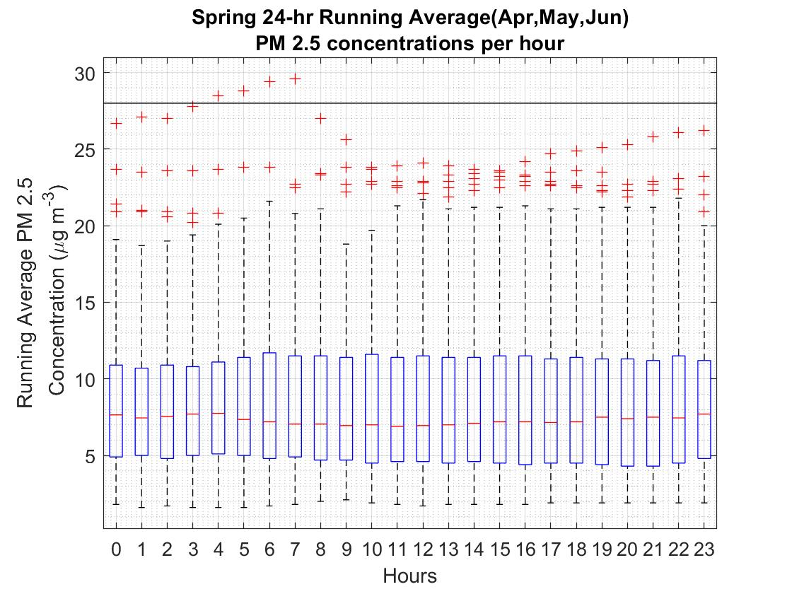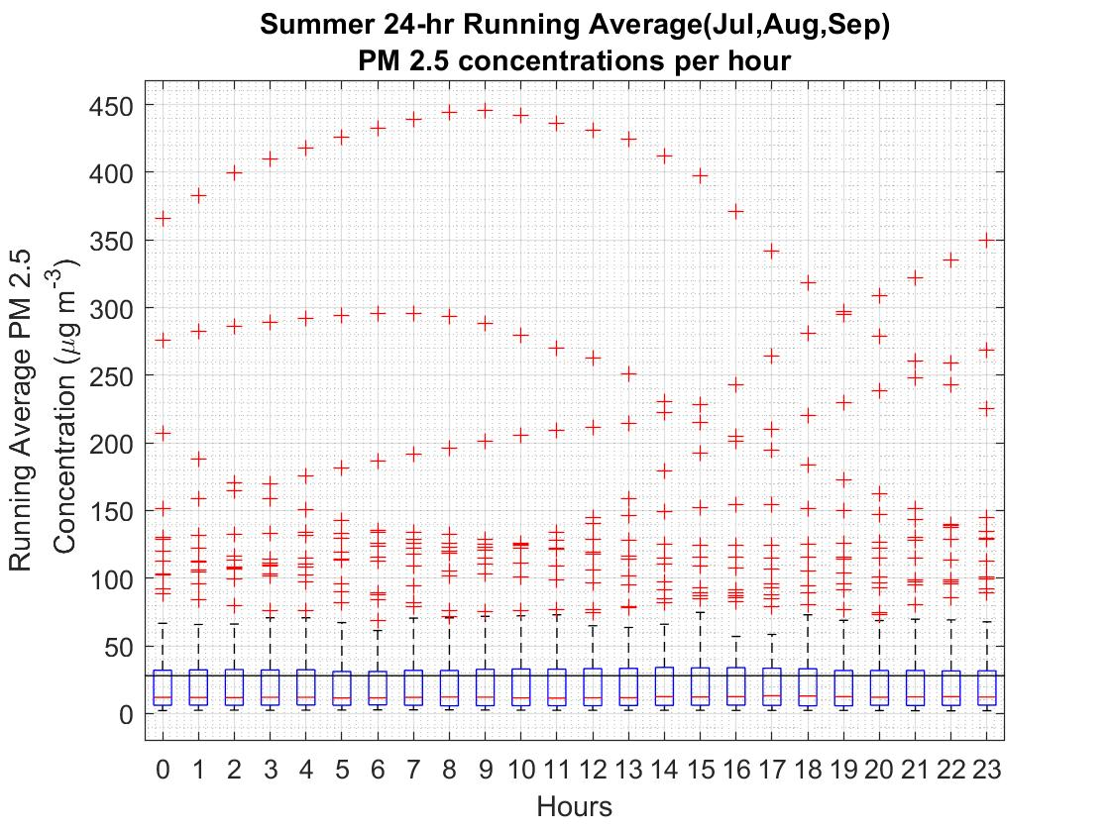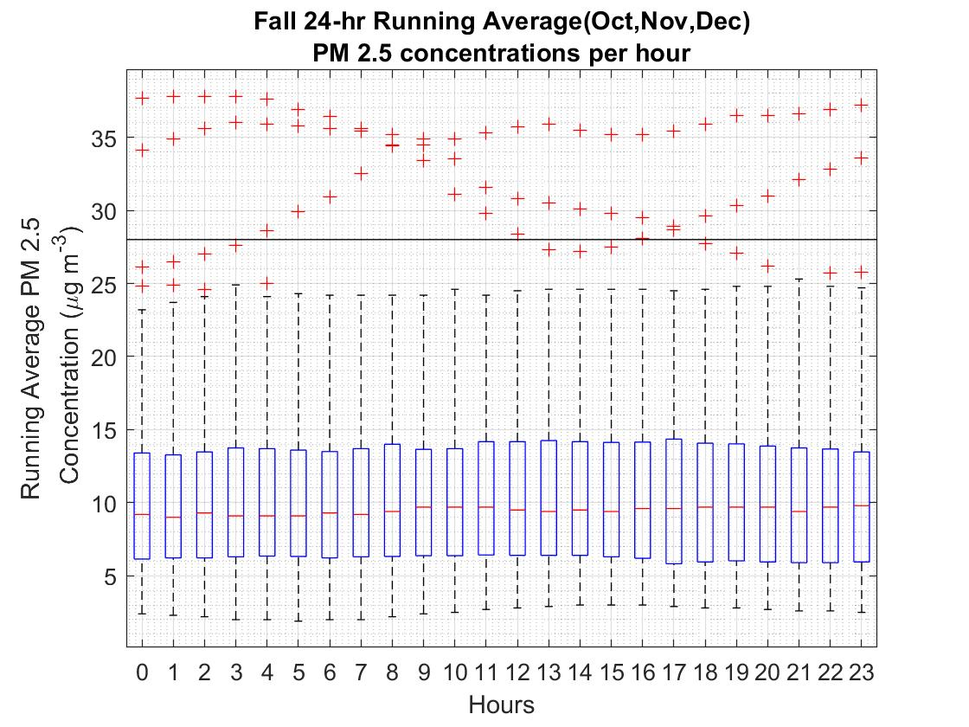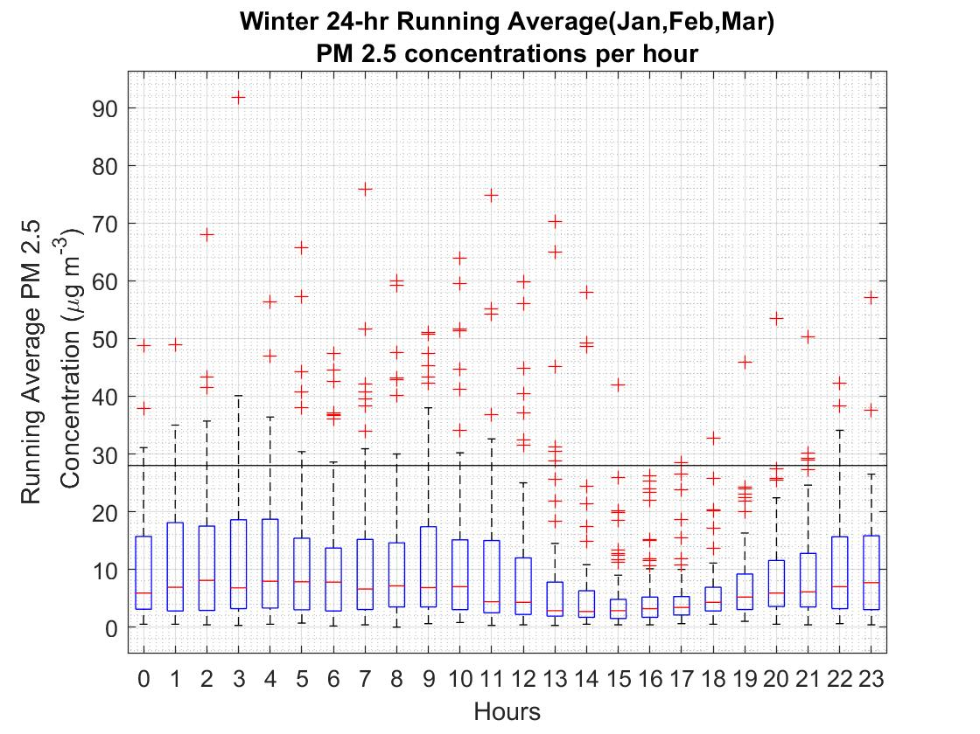

Discussion:

The observations made and data analyzed form a basis to research some of the sources and sinks that attribute to Prince George’s air quality. The PG airshed topography can be looked upon as a plateau with a few hills surrounding the major rivers. The Figure 2.1 topographic representation shows the Tabor Mountain to the east, Cranbrook Hill to the west, and the Hart Highland area to the north. Figure 2.1 shows that the topography lowers appreciably at the intersection of the rivers resulting in a topographic “bowl” effect.

This wind sheltered valley experiences frequent temperature inversions when a stable, cold layer of air is overlain by warmer air (BCMoE, 2016). Shallow (~100 m deep), surface-based inversions occur overnight due to surface cooling forming a stable nocturnal boundary layer which can explain the high PM concentrations seen overnight in Graphs 2,3,4 and 5. Deeper, elevated inversions that are more persistent occur due to subsidence associated with anticyclones. Winter meteorological conditions can create such anticyclones that can result in more frequent temperature inversions in the valley, less atmospheric mixing from daytime solar radiation reaching the surface, and consequently higher levels of PM2.5 pollution. We see this happen in Graphs 6 and 10, with higher variability in the median over the stretch of the day, larger Inter-Quartile Range (IQR) and even a greater fraction of hours with concentration reported above the CWS in the case of Graph 10. Winter snow cover will also result in less friction and so slower wind velocity, thereby decreasing the turbulence and creating light winds. These winds will remain over the airshed, creating persistent high PM2.5 concentrations in the bowl. Additionally two pulp mills and one oil refinery are less than 4 km northeast of Plaza and contribute significantly to ambient PM (both PM2.5 and PM10) measured there, especially when winds are from the northeast to southeast direction. The valley winds and thermally forced winds due to valley heating create a subsidence in the valley and force the pollution upslope during the day, creating the lower concentrations observed in Graphs 2-5 between noon to sunset. These specifically occur after noon because the surface is heated enough after this point to create a thermal pressure gradient that drives these upslope winds. After sunset this pressure gradient no longer exists and the pollution pools back down into the valley overnight. As for land use and urban sources, colder temperatures also result in higher heating during the winter, as well as more people using cars and automobiles to get around and more wood burning fireplaces. All of these contribute to higher emissions and consequently higher concentrations of PM2.5.

Spring and Fall on the other hand see relatively lower PM2.5 concentrations is because these emissions are suppressed by rain and snow fall. Spring melt of a snowpack can suppress road-dust emissions and seasonal rainfall in both fall and spring also dilute the concentrations. Graphs 7 and 9 thus on average remain under the CWS and have lower emissions. They also see lower variability because often rain and high winds indicate more turbulence and thus a well-mixed airshed throughout the day.

The PM2.5 peaks most during the summer months. Graph 11 shows the frequency of PM2.5 concentrations above the CWS of 28 µg m-3 . As it can be seen in the graph, the majority of these exceedances (58%) occurred from July-September as a result of wildfires (Figure 4), including the Chelaslie River wildfire that burned an unprecedented 1331 km2 of the Entiako Provincial Park just 200 km southwest of the station.

peak for dry conditions is thought to be primarily associated with forest fires and stagnation during anticyclonic periods resulting in fumigation events. The 2018 wildfire season was marked as the second worst in the province’s history, with more than more than 12,984 square kilometres of the province being burned by the end of August.

In 2014, 24 exceedances of the numerical 24-hour Provincial PM2.5 objective were observed at Plaza 400 (Figure 3). The majority of these exceedances (58%) occurred from July-September as a result of wildfires (Figure 4), including the Chelaslie River wildfire that burned an unprecedented 1331 km2 of the Entiako Provincial Park just 200 km southwest of the station. The remaining exceedances generally occurred during late winter periods when meteorological conditions can create stagnant conditions and wood burning appliances and other sources emit particulates that become trapped in the local air. Seasonal variations in PM2.5 concentrations are evident in the 2014 time series of both sites (Figure 4). The plot identifies the summer exceedances linked to wildfires and the winter events linked to meteorological conditions. The majority of exceedances occurred between July and September with other exceedance events occurring in November and February.